TECHNICAL PROJECT REPORT

# Title of Invention / Project:VOICE COMMAND LOCK

# Team Members / Inventors:

|  |  |  |  |  |  |
| --- | --- | --- | --- | --- | --- |
| **S. No.** | **Name** | **Department** | **Designation** | **Mobile** | **E-Mail** |
| 1. | Chilakam dinesh reddy | CSE(IOT) | Student | 6300126068 | chilakamdineshreddy@gmail.com |
| 2. | Thota Sai kumar | CSE(IOT) | Student | 9182168507 | saikumarpatelsai@gmail.com |
| 3. | Cheela Sai kumar | CSE(IOT) | Student | 8185005437 | Sai48301@gmail.com |
| 4. | sujith | CSE(IOT) | Student | 9701426097 | Sujithbarla35351@gmail.com |
| 5. | Mailaram sai vamshi | CSE(IOT) | Student | 8309304072 | Mailaram.saivamshi8096@gmail.com |
| 6. | Khushal Thakur | ECE | Mentor | 9646030764 | khushal.thakur@cumail.in |
| 7. | Anshul Sharma | ECE | Mentor | 9478697475 | anshulsharma.ece@cumail.in |
| 8. | Kiran Jot Singh | ECE | Mentor | 9463909689 | kiranjotsingh.ece@cumal.in |
| 9. | Divneet Singh Kapoor | ECE | Mentor | 9878422653 | divneet.ece@cumail.in |

Section – 1 (IPR Related)

# Brief Abstract (500 words):

* **Problem your project is solving?**
* Safe look system by giving voice commands.
* **How are you solving that (solution)?**
* By giving voice commands.
* **Additional modifications that can cater to improved solution?**
* By giving the voice commands in different languages.

# Existing state-of-the-art and Drawbacks in existing state-of-the-art

(*Brief background of the existing knowledge*)

|  |  |  |
| --- | --- | --- |
| **S. No.** | **Existing state of art** | **Drawbacks in existing state of art** |
| 1 | Opening the screen lock of electric devices | It need a proper voice commands and it can’t work without owner. |
| 2 |  |  |

# Novel/Additional modifications that you can propose to improve upon drawbacks

*(List down the features)*

* Opening the lock by using electric device and mechanical device.
* Any one can use it by giving correct voice commands.

# Advantages

(*List down the advantages, if each feature is incorporated)*

* It is more safe and easy to use.
* It is affordable by every persons to keep their things safe.

# Block Diagram

(*Functional diagram depicting the flow of information in your system. Do not define exact components, only use generic terms. Must include modifications as well.)*

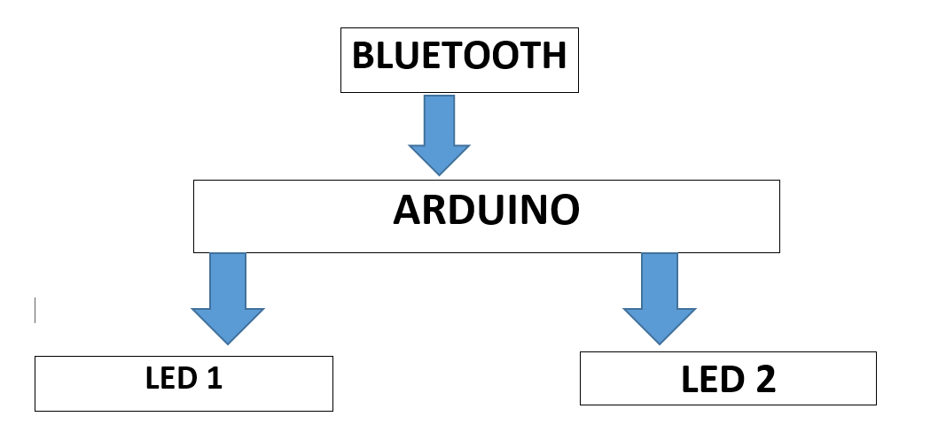

Section – 2 (Real Project)

# Materials

(*List down the Components, Equipment, etc. actually used in the project*)

1.One Arduino

2.One bluetooth

3.Two LEDS (blue,white)

4.Eight connecting wires

# Circuit Diagram

(*Fully functional circuit diagram with exact connections. Can use Fritzing/Proteus*)

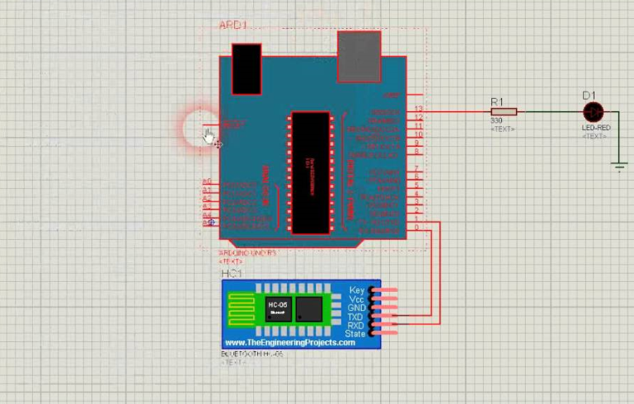

# Steps of Circuit Completion

(*Bifurcate the circuit completion in steps, specify with photographs, leading to final project)*

* Connect TX of Bluetooth to pin 11 , RX to pin 10,VCC to 5V of arduino.
* LED white to pin 2.
* LED blue to pin 3.

# Program Code

# [18BCS4527](https://gist.github.com/18BCS4527)/**[gist:fefde0342cd5afc35e54ba824c4bf34a](https://gist.github.com/18BCS4527/fefde0342cd5afc35e54ba824c4bf34a)**

